Date | BA (Hons) Education sessions
Monday 18th September 2023  Room: BSTC G.36 | 10.00 – 10.50  10:45 – 11:00  11.00 – 11.15  11.15 – 11.30  11.30 – 12.00  12.00 – 12.30  13:00 onwards: | Introduction icebreaker  Break  Welcome Talk by the head of school  Admin Talk  Tower Team Challenge  Individual Q&A  Fresher Week Activities
Tuesday 19th September 2023  Room: BSTC G.36 | 10:00 – 10:30  10:30 – 10:50  11.05 – 11.20  11:25 – 11:45  12:00 – 12:30  13:00 onwards | Timetable and module information  Programme Handbook Team Quiz  Break  Library induction  Team Orienteering  Freshers Week Activities
Wednesday 20th September 2023 | 10.00 – 12.00:  13.00 onwards | Stage 1 Module Fair - Herschel Learning Lab (HERB.1)  Fresher Week Activities
Thursday 21st September 2023  Room: BSTC G.33 | 09.00 – 12.30  11:30 - 12:00  12:00 – 12:30  13.00 – 14.00  13:30 – 14:00 | Canvas online induction materials; independent study  Coffee and Refreshments  Wellbeing Talk  Fresher Week Activity  NUSU Talk
Friday 22nd September 2023 | 09.00-13.00  Complete Canvas online induction (independent study). | Zoom/in-person individual meetings with personal tutors and group meetings with peer mentors
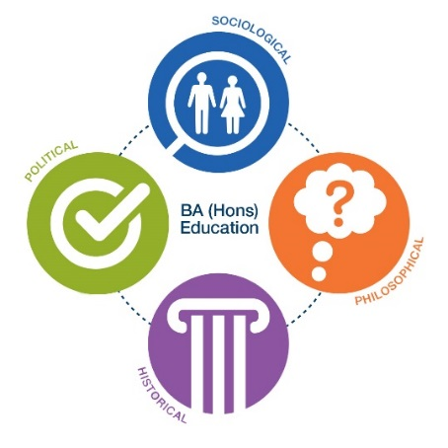
BA (Hons) Education
Induction Week Timetable
Stage 1

